Math Dictionary
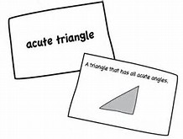

Directions: Make a Math Dictionary using note cards. For each of the key math vocab words make one note card.
Front Back
Term | Definition  example

Examples:

Substitution: "Substitution" means putting numbers where the letters are.
Example:
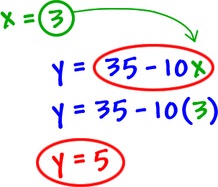

Distribution: Always multiply what is on the outside of the parenthesis with everything on the inside
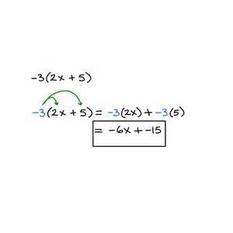
Exponent: The number of times a number is to be multiplied by itself

Example:
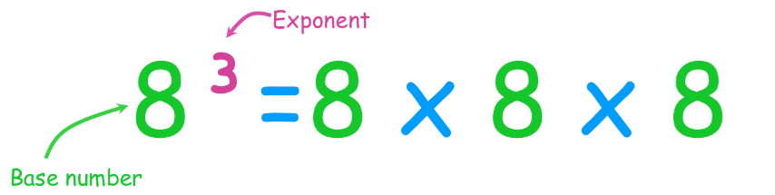

Ratios: cross multiply and then divide
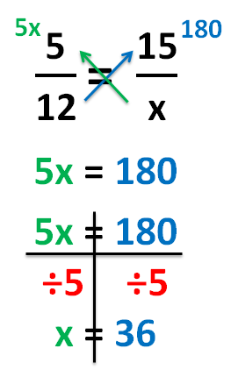

Greater than: The alligator’s mouth is open towards the greater number
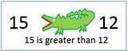

Less than: The alligator’s tail faces the lesser number
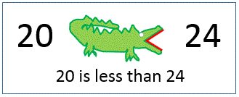

Dividing Fractions: Keep change Flip
Keep the first fraction change division to multiplication and flip the last fraction
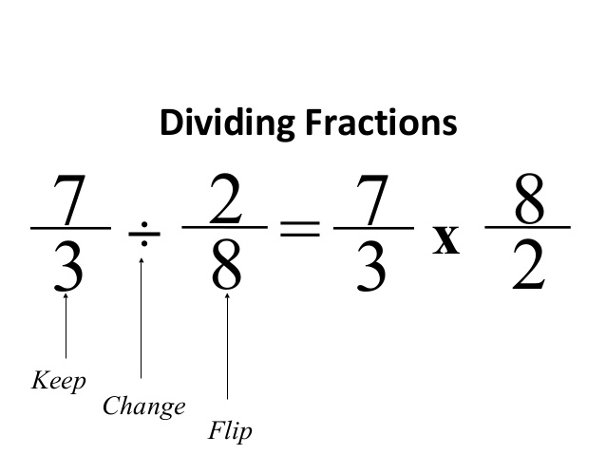

Change decimal to a percent: Move the decimal two places to the right
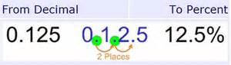

Change percent to a decimal: Move the decimal two places to the left
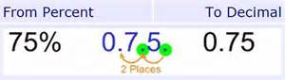

___% of a number: Change percent to a decimal than multiply (of means multiply)
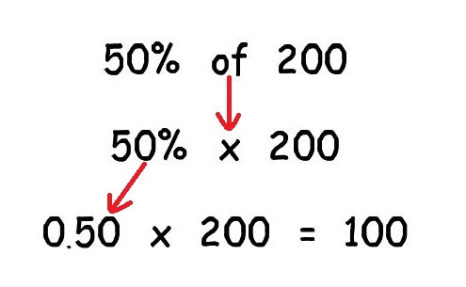

Given Number is what percent of another number

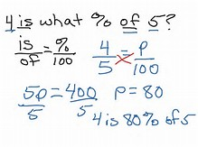

Vocab Words:
Substitution
Distribution
Exponents
Ratio
Greater than
Less than
Dividing Fractions (Keep change Flip)

