Philosophical Chairs
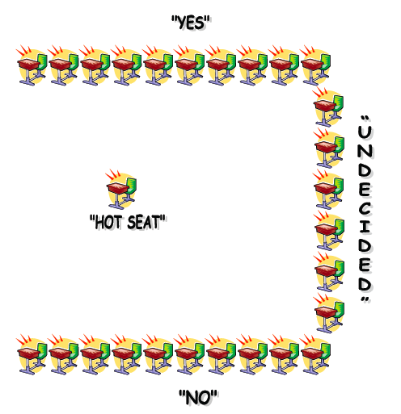
Getting a whole class of students to discuss a philosophical problem at length is frequently difficult to do. There is a constant tension between listening, participation and critical thought. The method of philosophical chairs seeks to address the issue of student participation by changing the physical environment of the classroom.
The classroom is divided into a horseshoe shape. Students are asked to divide on whether they agree or disagree with the statement and sit on opposing rows. A member of the pro faction begins the discussion, giving her reasons for her agreement with the proposition. This is followed by spokesperson from the con faction. If anyone changes her opinion in the course of discussion, she should move herself to the opposing or undecided row. At the end of the exercise students are encouraged to evaluate the discussion. In classes where the technique is first used, it can be helpful to have students discuss the activity itself.
It is worth discussing the method with the students prior to running it as this will give them the opportunity to familiarize themselves with it and also to voice any potential reservations. It is important for students to recognize that the aim of the exercise is to modify one's opinion under the influence of the discussion rather than to firmly maintain one's beliefs. The teacher's role is that of moderator but on occasion, particularly with more controversial topics the teacher may have to act as referee.
In terms of the choice of topic it need not necessarily be a standard philosophical or ethical issue. The most important point is that the topic divides people. The activity is a philosophical one. Students should not be able to invoke factual knowledge as a means of settling the issue. The proposition should deal in definitions or be undecidable. The point of the exercise is not to arrive at a decision but to reach a clearer understanding of what might constitute a decision on the particular issue.
Undecided students tend to be of three kinds: truly divided between the pros and cons of an issue; those who feel they need more time to decide; and those who feel uneasy in discussions. The undecided group is typically smaller at the end than at the beginning.
The benefits of philosophical chairs are that students obtain intensive practice in weighing the supporting and opposing arguments in a discussion. They develop sensitivity to their own and other's opinions. Students leave the class feeling that they have participated in a genuine discussion. Any activity that encourages students to participate and to listen carefully to others' arguments can only be welcomed. Philosophical chairs seems an excellent means to achieve these aims. Most students will respond enthusiastically to the physical movement aspect.
A number of points need to be considered for anyone attempting to use this technique. First, some students may feel uncomfortable being on public display in this way. Second, there are issues of access for students with disability. How, for instance, would a wheelchair bound student be able to participate in an activity that requires physical movement? Students may have to be introduced to this kind of activity gradually.
It might prove useful to give students a short time at the end to write up the discussion in their notes. It may also help if the teacher sums up at the end, possibly highlighting the ways in which the discussion relates to current content.
Procedures
- Students read an article, short story, essay or literary selection, taking notes as they read.
- Students are then presented with a critical thinking question that will elicit thought and discussion.
- Chairs are then placed in the horseshoe arrangement.
- Students will then argue the merits of the question and that their choice of seat during the discussion will illustrate their position. They will have the opportunity to move as their minds change.
- Encourage each student to speak at least two times.
Tips for the Teacher
- Set a time limit for the debate.
- Students will address each other by their first names.
- A student must briefly summarize the previous speaker's points to that speaker's satisfaction before he/she begins his/her own comments.
- Think before you speak. Organize your thoughts and signpost. (“I have three points; first…”)
- After a student speaks, he/she must wait until two students other on his/her side have spoken before speaking again.
- One speaker at a time; others are listeners.
- The teacher can call time-out periodically to clarify, reflect on the process or content, or refocus.
- Address the ideas, NOT the person.
- One student from each team will provide a summary of the viewpoints presented during the discussion by his/her team.
- A student in the neutral zone must take notes on both sides of the argument, and if his/her position changes, he/she must explain why he/she came to a new conclusion.
- Students write a metacognitive reflection responding to questions either related to the material read or to the technique of Philosophical Chairs.

Sample Questions/Opening Statements

- While reading “Civil Disobedience” by Henry David Thoreau:
  - “The government is best which governs the least.” If acts of civil disobedience do not harm the government or its people, then jailing those who commit those acts is useless.
- The US should not sell arms to any foreign country.
- It is the duty of the US to send money to foreign countries suffering from poverty and lack of food.
Philosophical Chairs – Student Guidelines
- Read the material for the debate and the opening statement carefully; be sure you understand it.
- Listen to the person who is speaking.
- Understand the person’s point of view.
- Contribute your own thoughts, offering your reasons as succinctly as possible.
- Respond to statements only, not to the personality of the person presenting it.
- Change your mind about the statement as new information or reasoning is presented.
- Move to the opposite side or to the undecided chairs as your thinking grows and changes.
- Support the Mediator in maintaining order and helping the discussion to progress.
- Reflect on the experience via the closing activity or assignment.
Philosophical Chairs Reflection
Please respond openly and specifically to the following questions:
- What was the most frustrating part of the exercise?

- What was the most successful part of the exercise?

- What was said that caused you to change your seat, or what was said that caused you to not change your seat?

- What conclusions can you draw about how you form your beliefs?

- What conclusion can you draw about the nature of forming beliefs as it might relate to this activity?

